AWS Connectivity Documentation - Terminal, VNC, and S3

There are two ways of connecting to AWS Server Machine:
- AWS Terminal via Session Manager
- AWS Server Remote via VNC Viewer

AWS Terminal via Session Manager
Below are the steps to connect to AWS Server as Terminal: (Consider connecting Devel14a)
- Open AWS Access Portal.
- Go to GPDM-WINDCHILL-SBX account and click on AWSPowerUserAcess which will open new window in new tab.
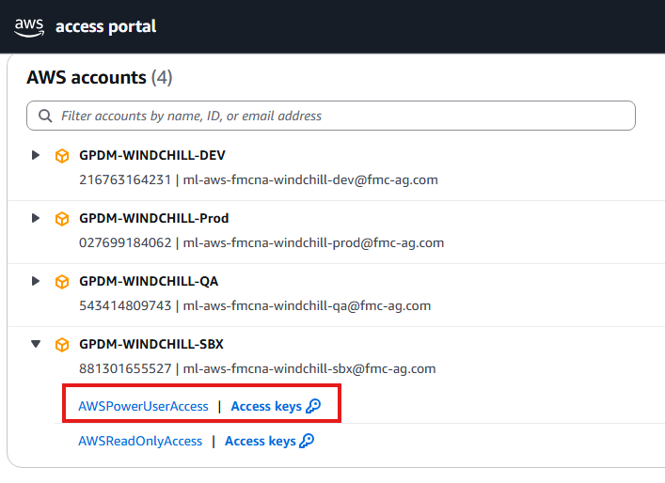

- Search for Session Manager and click WC-TWX-INT-2, start the session.
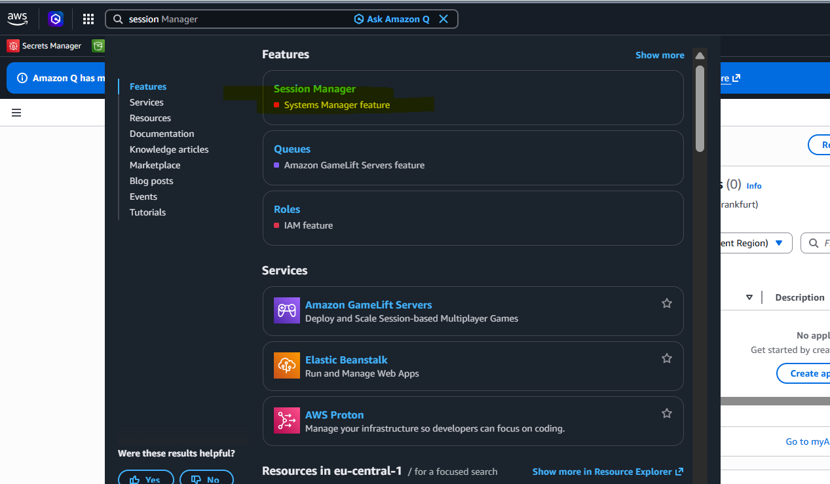

- Click on Start Session, select DEVEL 14a as Target Instance and click on Start Session.
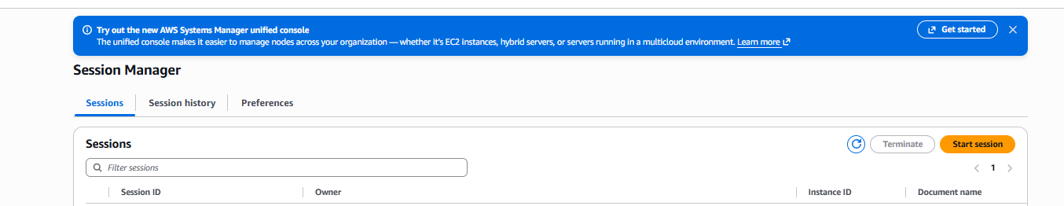
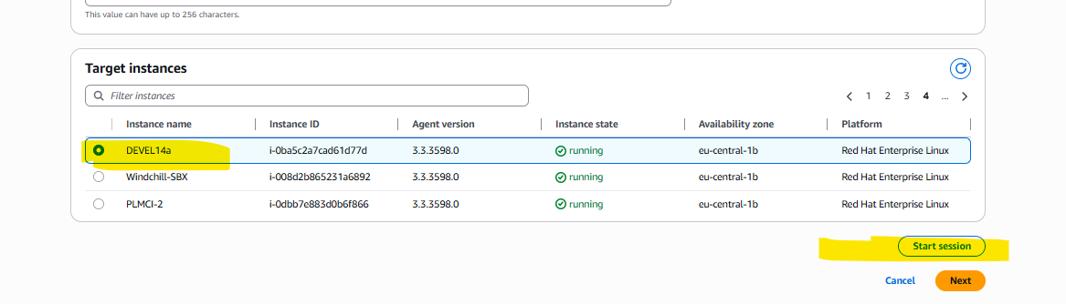
- Terminal will open in new tab.
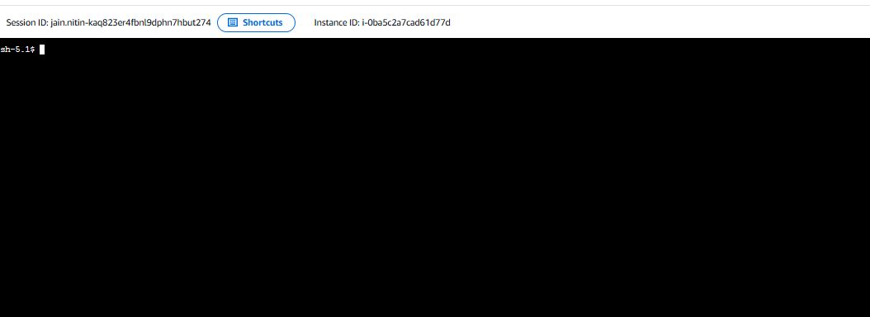
- Type sudo su in Terminal which will allow you to open an interactive shell as the root.
Press Enter.
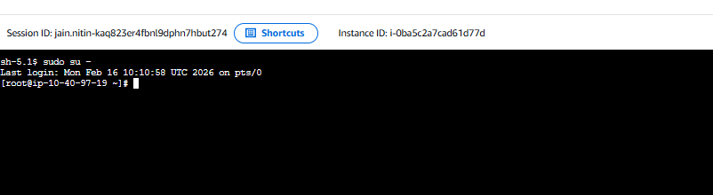

- Validate whether VNCServer is started or not,
Please follow the instructions below:
- Type vncserver -list press enter. If no server is started it should be blank.
- If no server is available on the above screen, we need to start the VNCServer.
- To start the server type vncserver :2 and press enter.
- Once we have started the server, type vncserver –list and press enter.
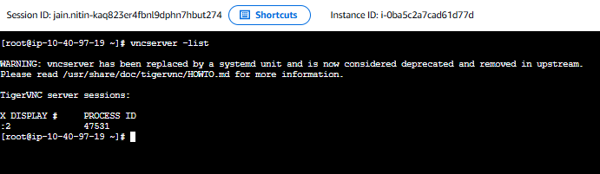

AWS Server Remote via VNC Viewer
Below are the steps to connect to AWS Server as Remote:
- Login to AWS Console sung
- Change the region to Europe (Frankfurt).
- Locate `GPDM-Windchill-SBX` in the list of servers.
- Click on Access Keys.
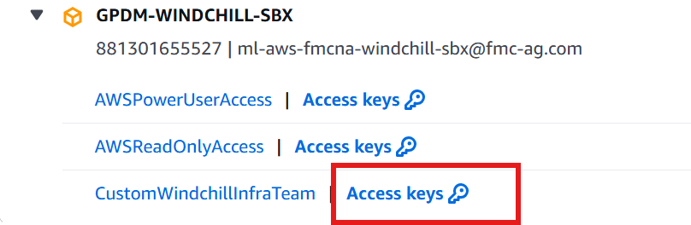
- Copy the access token for PowerShell.
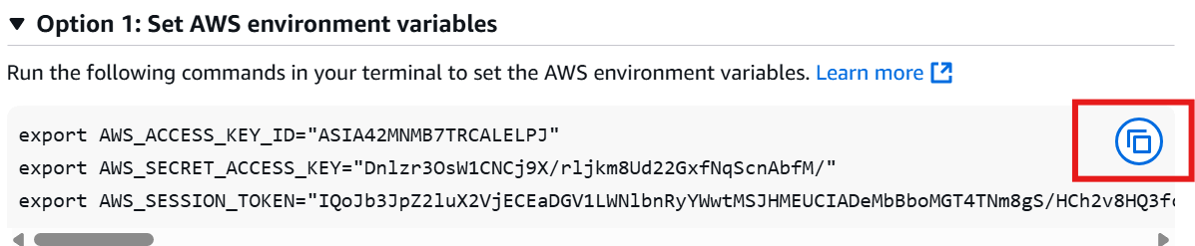
- Open Powershell and paste the copied access token.
- Set the AWS region to Europe(Frankfurt): (If required, need to set once)
aws configure set region eu-central-1
- In AWS Console, search for EC2, Resources → Instances.
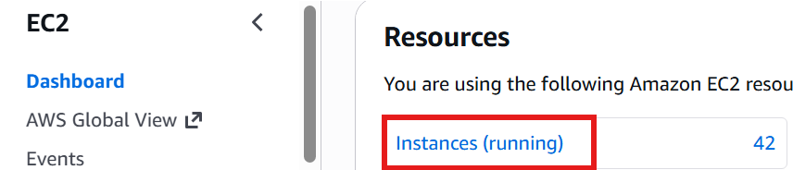
- Search for the instance you want to connect to and copy the Instance ID.
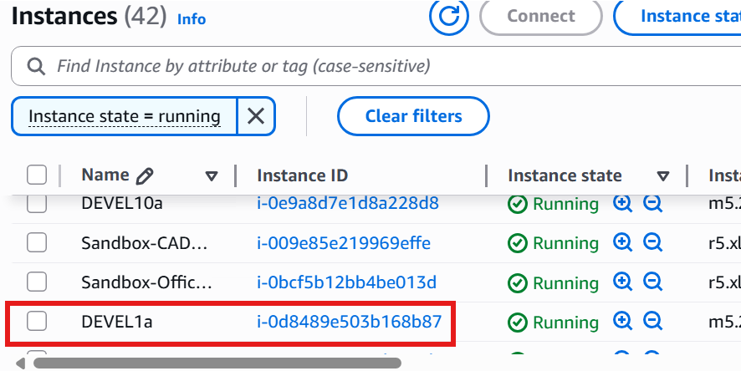
- Run the following command (replace <INSTANCE ID> with the actual ID):
aws ssm start-session --target <INSTANCE ID> --document-name AWS-StartPortForwardingSession --parameters portNumber=5902,localPortNumber=5918
- Launch TigerVNC or RealVNC software, Type locatlhost:5918 and click on Connect.
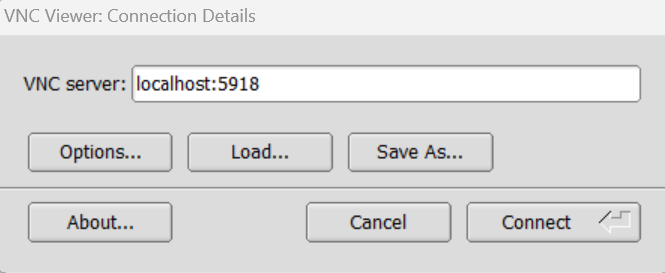
This will prompt for the password.

- In AWS Console, open Secret Manager, click on the server and click on ‘Retrieve secret value.
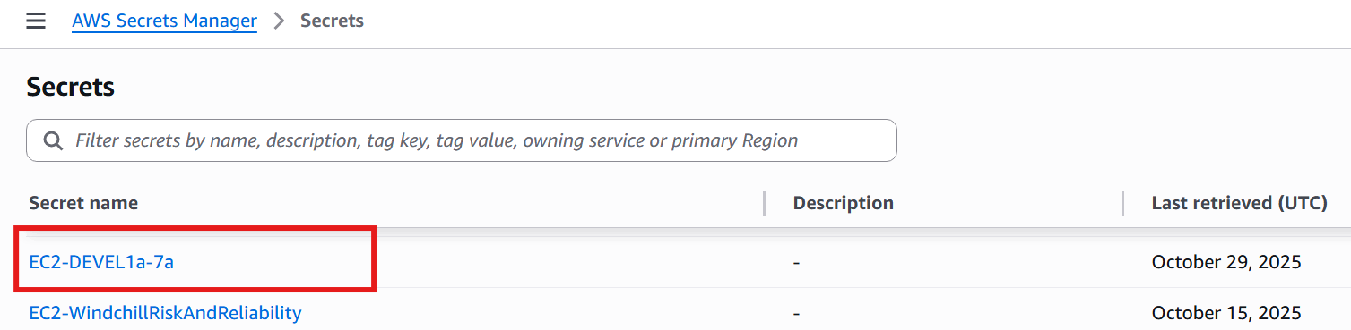
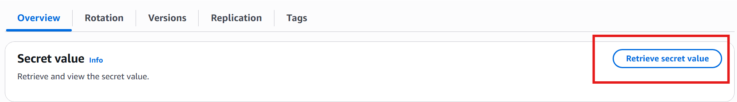
Paste the secret value into the VM login prompt (Step 11)

AWS Server – Files upload and download from/to S3
Process to transfer files from/to S3 bucket.
S3 to Server:
aws s3 cp <S3_file_url> <directory_of_Server_machine>
Server to S3:
aws s3 cp <Full_Filename> <S3_folder_url>

